Precision Medicine Call to Action: Deciphering the Genetic Code
in Clinical Practice
At the conclusion of this knowledge based program attendees should be able to:
- Define precision medicine and pharmacogenomics.
- Evaluate the significance of pharmacogenomics on current and future clinical practice.
- Apply pharmacogenomics guidelines and additional resources to clinical scenarios.
- Describe how personal pharmacogenomics testing will likely affect the future of clinician education.
- Discuss the need for patient advocacy in regards to precision medicine.

Speaker: Daniel Crona, PharmD, PhD
Assistant Professor
UNC Eshelman School of Pharmacy

Activity Number: 0046-0000-15-118-L01-P

Date: April 27, 2016
Time:
Place: NC Board of Pharmacy
6015 Farrington Road, Suite 201
Chapel Hill, NC 27517

CE Hours: 1.00

Target Audience: Pharmacists

Accreditation:
Statements of credit can be viewed and printed from CPE Monitor. Statements of credit will no longer be printed and mailed to the participant. **No partial credit will be given for any course**
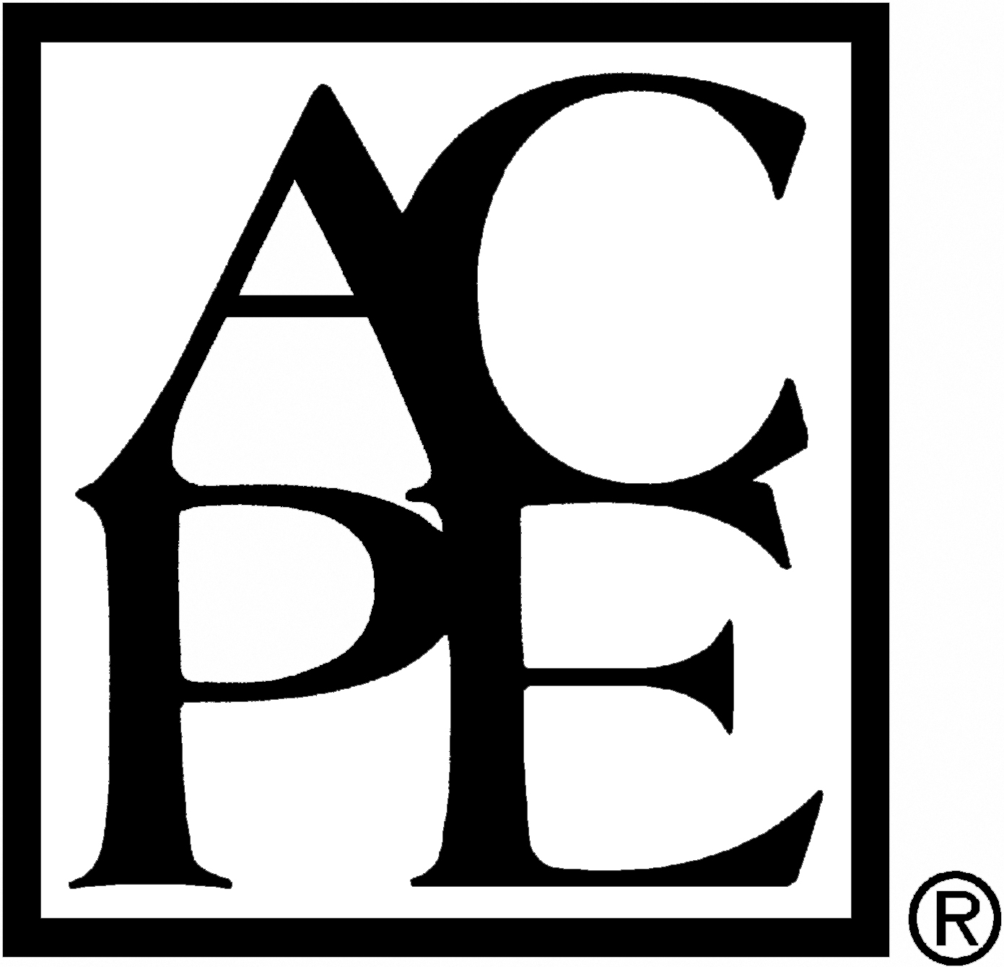 | The University of North Carolina Eshelman School of Pharmacy is accredited by the Accreditation Council for Pharmacy Education as a provider of continuing pharmacy education.

Fee: Free

